Project Case | 
ISYS6197
Business Application Development
Computer Science | E192-ISYS6197-LV01-00
Valid on Even Semester Year 2018/2019 | Revision 00

- Seluruh kelompok tidak diperkenankan untuk:
The whole group is not allowed to:
    - Melihat sebagian atau seluruh proyek kelompok lain,
Seeing a part or the whole project from other groups
    - Menyadur sebagian maupun seluruh proyek dari buku,
Adapted a part or the whole project from the book
    - Mendownload sebagian maupun seluruh proyek dari internet,
Downloading a part or the whole project from the internet,
    - Mengerjakan soal yang tidak sesuai dengan tema yang ada di soal proyek,
Working with another theme which is not in accordance with the existing theme in the matter of the project,
    - Melakukan tindakan kecurangan lainnya,
Committing other dishonest actions,
    - Secara sengaja maupun tidak sengaja melakukan segala tindakan kelalaian yang menyebabkan hasil karyanya berhasil dicontek oleh orang lain / kelompok lain.
Accidentally or intentionally conduct any failure action that cause the results of the project was copied by someone else / other groups.

- Jika kelompok terbukti melakukan tindakan seperti yang dijelaskan butir 1 di atas, maka nilai kelompok yang melakukan kecurangan (menyontek maupun dicontek) akan di – NOL – kan.
If the group is proved to the actions described in point 1 above, the score of the group which committed dishonest acts (cheating or being cheated) will be “Zero”

- Perhatikan jadwal pengumpulan proyek, segala jenis pengumpulan proyek di luar jadwal tidak dilayani.
Pay attention to the submission schedule for the project, all kinds of submission outside the project schedule will not be accepted

- Jangan lupa untuk melihat kriteria penilaian proyek yang ditempel di papan pengumuman, atau tanya asisten anda.
Don’t forget to look at the project assessment criteria that posted on the announcement board, or ask your teaching assistant.

- Persentase penilaiaan untuk matakuliah ini adalah sebagai berikut:
Marking percentage for this subject is described as follows:

Tugas Mandiri  Assignment | Proyek  Project | UAP  Final Exam
40% | 60% | -

- Software yang digunakan pada matakuliah ini adalah sebagai berikut:
Software will be used in this subject are described as follows:

Software
Software
Java 8
Eclipse Neon 2
XAMPP 3.22 (MySQL)
MySQL Java Connection Library
- Ekstensi file yang harus disertakan dalam pengumpulan tugas mandiri dan proyek untuk matakuliah ini adalah sebagai berikut:
File extensions should be included in assignment and project collection for this subject are described as follows:

Tugas Mandiri  Assignment | Proyek  Project
JAVA, CLASS | JAVA, CLASS, SQL, image files(JPG/PNG/GIF)

Soal
Case
Watches Dealer

Watches Dealer is a shop that sells luxury watches such as Rolex, Omega, Patek Philippe, etc. To manage all the transactions and the system of the shop, the Watches Dealer shop’s owner has asked you to create a program for the store. The program should be made using Java Programming Language.

There are some requirements to build this application:
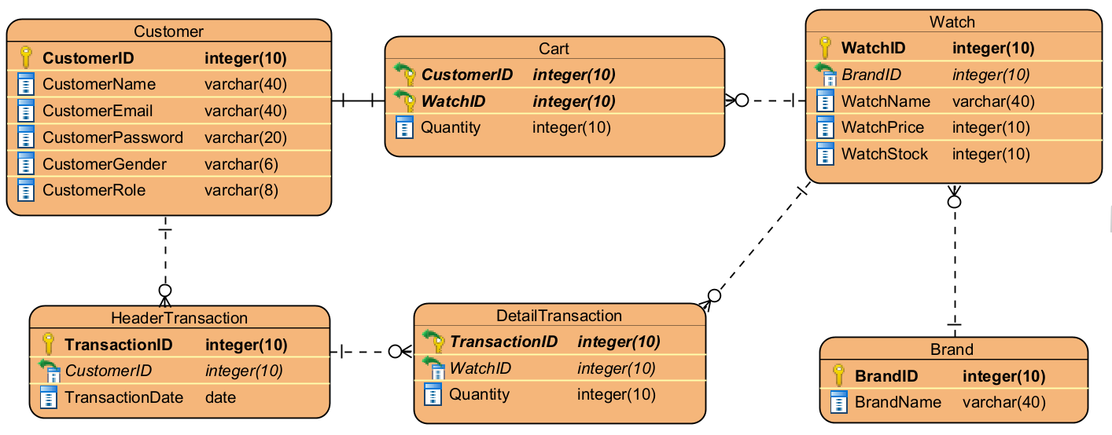
Execute the provided create and insert query file on the “watchesdealer” database! (“create+insert.sql”)

1. Login Form
This is the first form that will appear when the program is run. Login Form is used by users to Login so the users can access the Main Form.
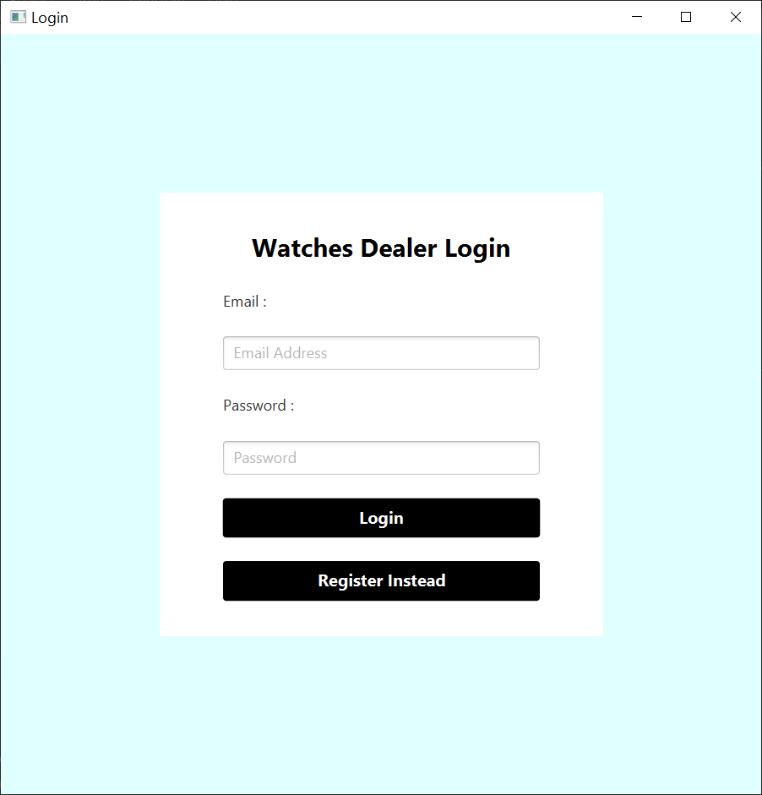
Figure 1. Login Form
Components:
- Label for Title, Email, and Password.
- TextField for input Email.
- PasswordField for input Password.
- Button for Login and Register Instead.
Description:
- If the user clicks the Login button, then validate:
- Email field must be filled.
- Password field must be filled.
- Email and Password must be correct compared to the existing data in the database.
- If the credential does not match any existing data in the database, display the error message using Alert.
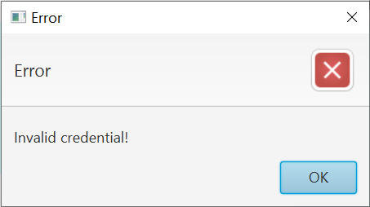
Figure 2. Invalid Credential Error Message
- If the user has successfully login, then the program will close the Login Form and open the Main Form.
- If the user clicked the Register Instead button, then the program will close the Login Form and open the Register Form.
(Additional note: every error occurrence will be shown on error message using Alert).

2. Register Form
Register Form is used by users to Register themselves.
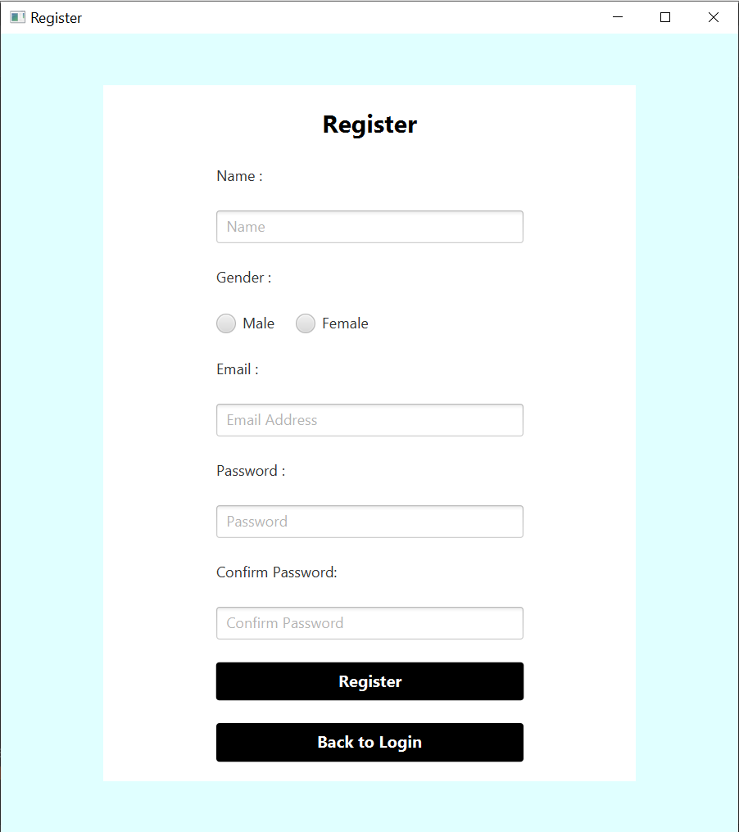
Figure 3. Register Form
Components:
- Label for Title, Name, Gender, Email, Password, and Confirm Password.
- TextField for input Email and Name.
- RadioButton for choosing Gender.
- PasswordField for input Password and Confirm Password.
- Button for Register and Back to Login.
Description:
- If the user clicks the Register button, then validate:
- Name length must be between 5 - 40 characters.
- Gender must be chosen, either “Male” or “Female”.
- Email must be in the valid format:
[email]@[provider].[domain]
- Password length must be between 6 - 20 characters.
- Confirm Password must be same as Password.

- When registering a new user, the user role is always going to be “Customer”.
- When the user successfully registered, insert a new user into the database, then the program will show a success message using Alert. Lastly, the program will close Register Form and open the Login Form.
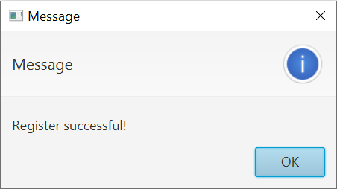
Figure 4. Register Successful Message
(Additional note: every error occurrence will be shown on error message using Alert).

3. Main Form
This is the main form of the program. In this form, the user can select the menu from the menu bar, such as User Menu (Logout), Transaction Menu (Buy Watch and My Transaction History), and Management Menu (Manage Product and Manage Brand). The menu that is shown is determined by the user’s role. If the user role is “Customer”, then the available menus are only the User Menu and the Transaction Menu. If the user role is “Admin”, then the available menus are only the User Menu and Management Menu.
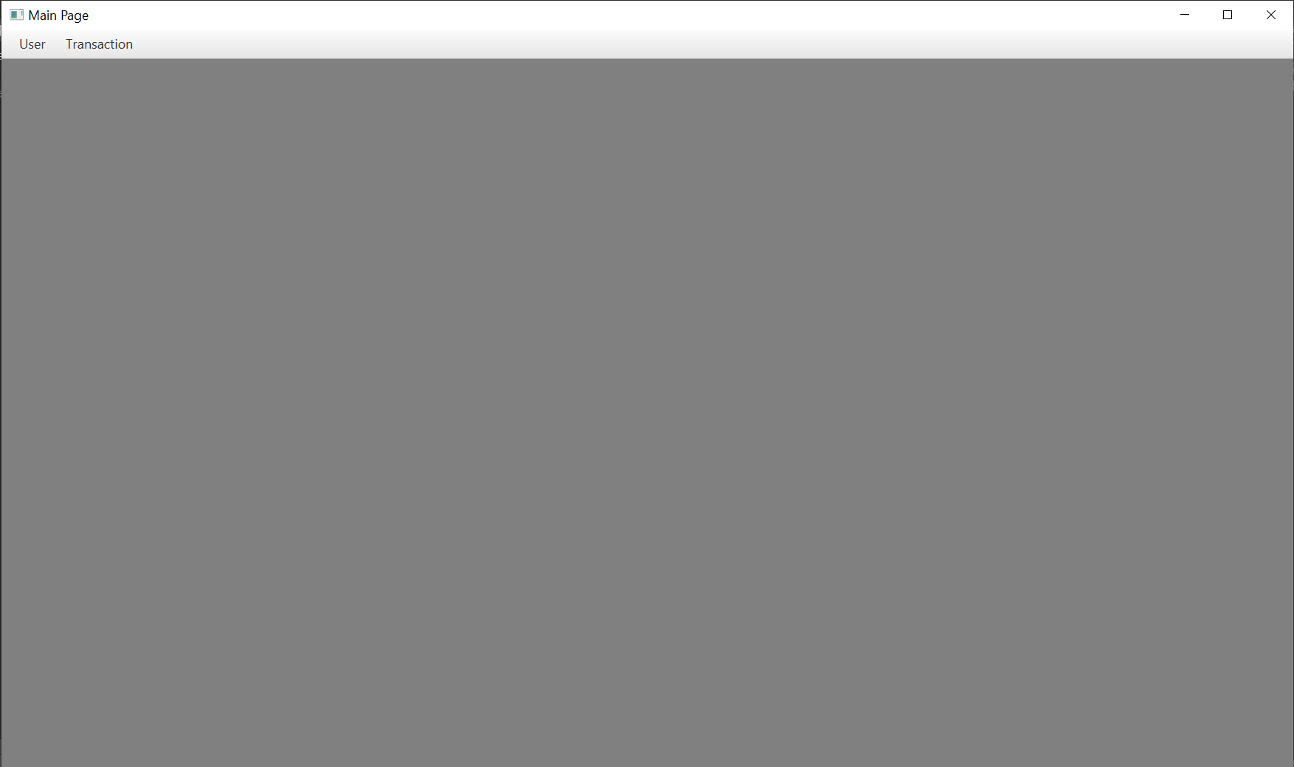
Figure 5. Main Form (Customer POV)
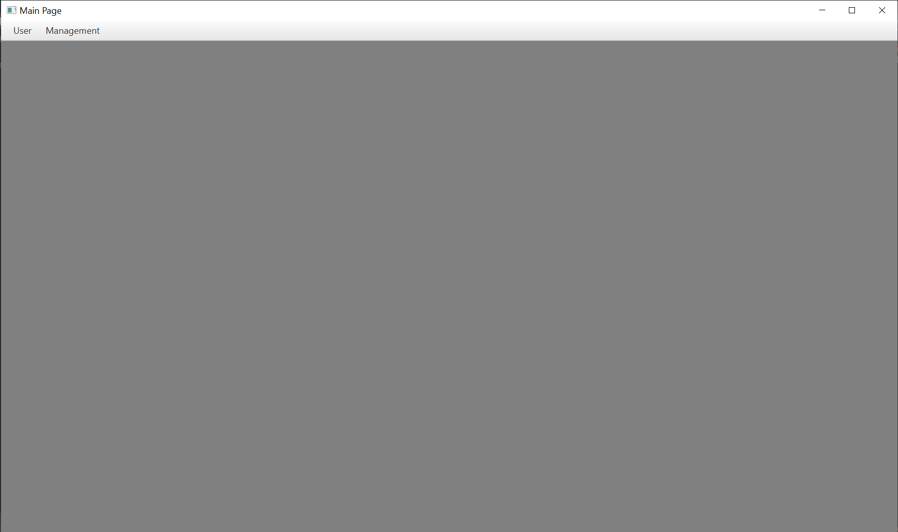
Figure 6. Main Form (Admin POV)
Components:
- MenuBar for the Menu Bar.
- Customer Role:
- Menu for User Menu and Transaction Menu.
- MenuItem for Logout, Buy Watch, and My Transaction History.
- Admin Role:
- Menu for User Menu and Management Menu.
- MenuItem for Logout, Manage Product, and Manage Brand.
Description:
- The program will check whether the user’s role is “Customer” or “Admin”, then display the available Menus & Menu Items according to their role.
- Customer Role
There will be 2 Menu displayed:
- User
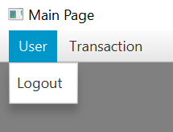
Figure 7. Customer: User Menu
- If the user clicks the Logout Menu Item, then the program will close Main Form and open the Login Form.
- Transaction
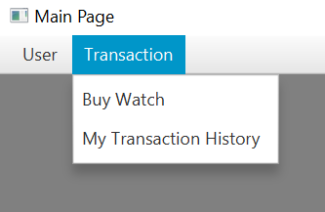
Figure 8. Customer: Transaction Menu
- If the user clicks the Buy Watch Menu Item, then the program will open the Buy Product Form inside the Main Form.
- If the user clicks the My Transaction History Menu Item, then the program will open the View Transaction History Form inside the Main Form.
- Admin Role
There will be 2 Menu displayed:
- User
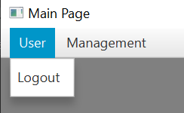
Figure 9. Admin: User Menu
- If the user clicks the Logout Menu Item, then the program will close Main Form and open the Login Form.
- Management
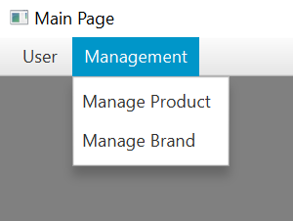
Figure 10. Admin: Management Menu
- If the user clicks the Manage Product Menu Item, then the program will open the Manage Product Form inside the Main Form.
- If the user clicks the Manage Brand Menu Item, then the program will open the Manage Brand Form inside the Main Form.

4. Buy Product Form
This form displays all the currently available watches. In this form, the user can click any product from the table to select it and add it to the cart. There will also be a table at the bottom that displays the current cart’s content.
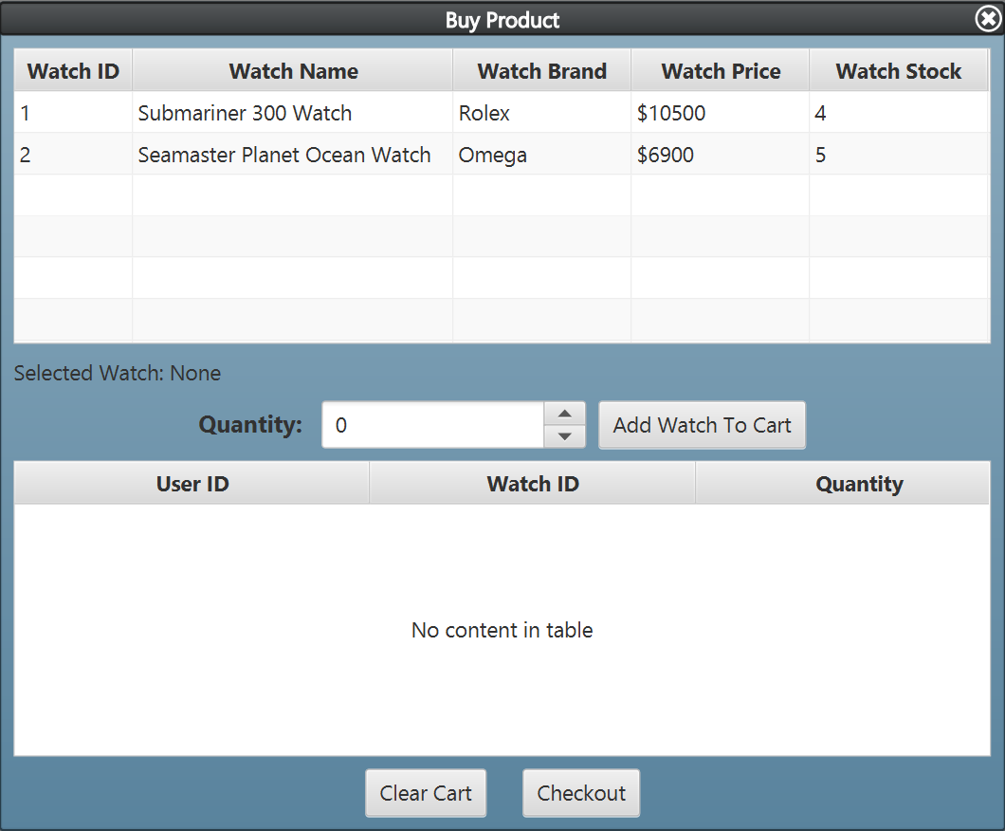
Figure 11. Buy Product Form (Default View)
Components:
- TableView for Product Table and Cart Table.
- Label for Selected Watch and Quantity.
- Spinner for input Quantity.
- Button for Add Watch to Cart, Clear Cart, and Checkout.
Description:
- By default:
- Quantity will start at 0.
- Selected Watch is None.
- The Cart Table will display the user’s cart from the database table.
- When the user selects one of the watches from the product table, change the Selected Watch label according to the selected watch’s name.
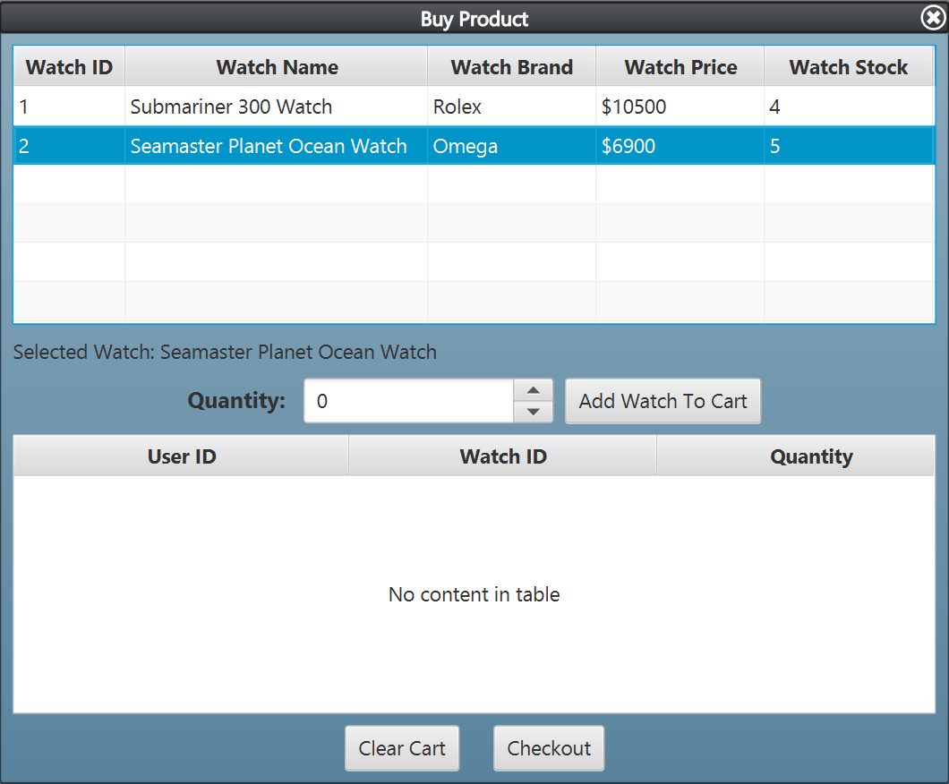
Figure 12. Buy Product Form (With One of The Watch Selected)

- If the user clicks the Add to Cart Button, then validate:
- A watch must be selected from the Product Table.
- Quantity must be bigger than 0 and not higher than the stock.
- If the user clicks the Checkout Button, then validate:
- Cart must not be empty.

- If the user clicks the Add to Cart Button but haven’t selected any watch from the Product Table, then show the error message using Alert.
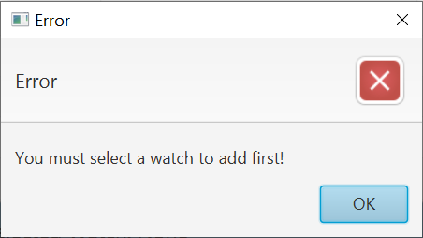
Figure 13. Watch Must Be Selected Error Message
- When the user successfully add to cart, insert the selected product into the user’s cart.
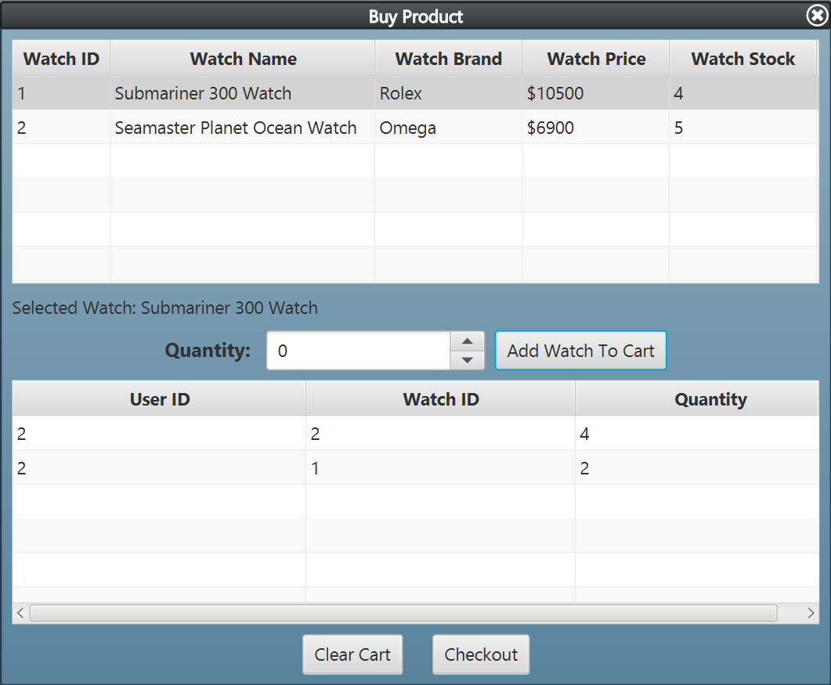
Figure 14. Buy Product Form (With Watches Added to Cart)
- If the user clicks the Clear Cart Button, the program will ask confirmation first using Alert and if the user chooses yes, then the program will delete all products from the user’s cart.
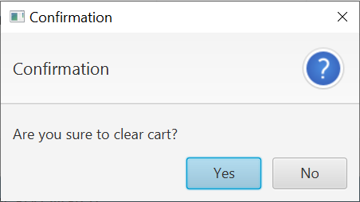
Figure 15. Clear Cart Confirmation Message
- When the user successfully checkout, the program will ask confirmation first using Alert and if the user chooses yes, the program will insert a new transaction into the database and delete all products from the user’s cart. The program should also reset the Quantity and the Selected Watch to default. Lastly, the program will show a success message using Alert.
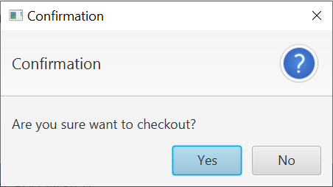
Figure 16. Checkout Confirmation Message
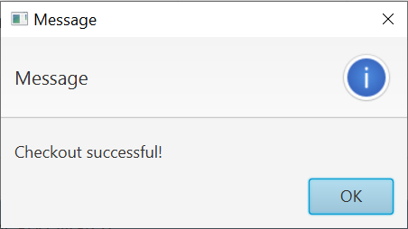
Figure 17. Checkout Successful Message
(Additional note: every error occurrence will be shown on error message using Alert).

5. View Transaction History Form
This form allows the user to view all transactions that the user has made. They can also view the details of each transaction.
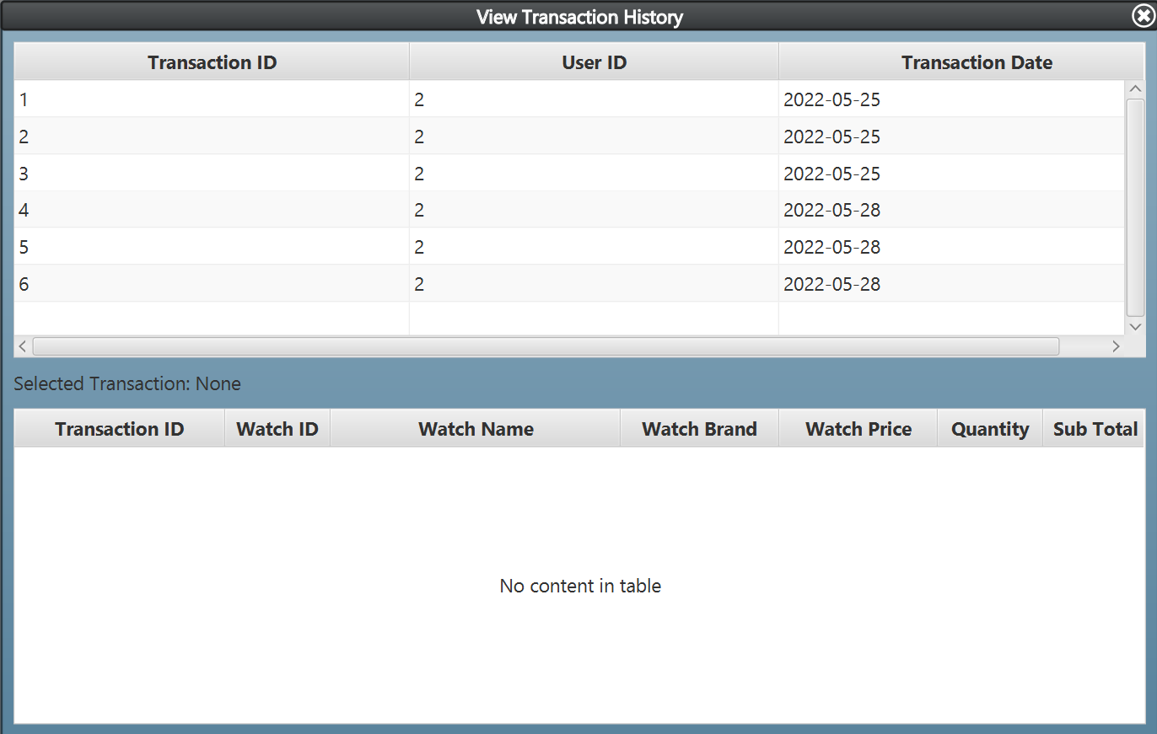
Figure 18. View Transaction History Form (Default View)
Components:
- TableView for Transaction Header Table and Transaction Detail Table.
- Label for Selected Transaction.
Description:
- By default:
- Selected Transaction is None.
- When the user selects one of the watches from the Transaction Header Table, the program will display the details of the selected transaction in the Transaction Detail Table. The program will also change the Selected Transaction label according to the selected transaction’s name.
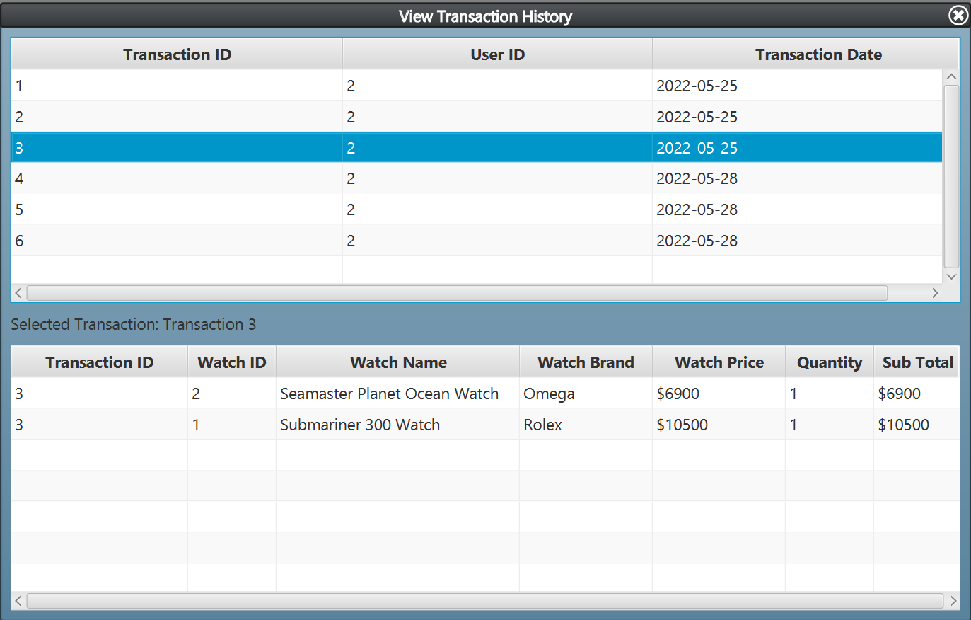
Figure 19. View Transaction History Form (With One of The Transaction Selected)
- The Transaction Date column of the Transaction Header Table is obtained from the date when the transaction happened.
- The Sub Total column of the Transaction Detail Table is obtained from Watch Price multiplied by Quantity.

6. Manage Product
This form is made for admins to manage the watches. Here, admins can insert a new watch, update any existing watch data, and delete any existing watch.
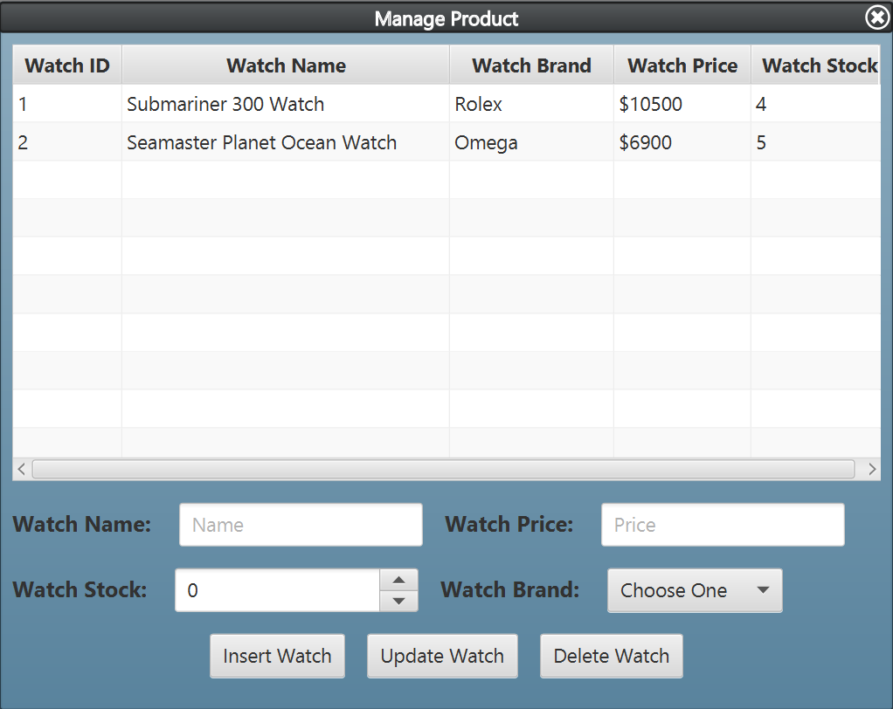
Figure 20. Manage Product Form (Default View)
Components:
- TableView for Product Table.
- Label for Watch Name, Watch Price, Watch Stock, and Watch Brand.
- TextField for input Watch Name and Watch Price.
- Spinner for input Watch Stock.
- ComboBox for input Watch Brand.
- Button for Insert Watch, Update Watch, and Delete Watch.
Description:
- By default:
- Watch Stock will start at 0.
- When the user selects one of the watches from the Product Table, the program will autofill all input fields (Watch Name, Watch Price, Watch Stock, and Watch Brand) with the selected watch’s corresponding values.
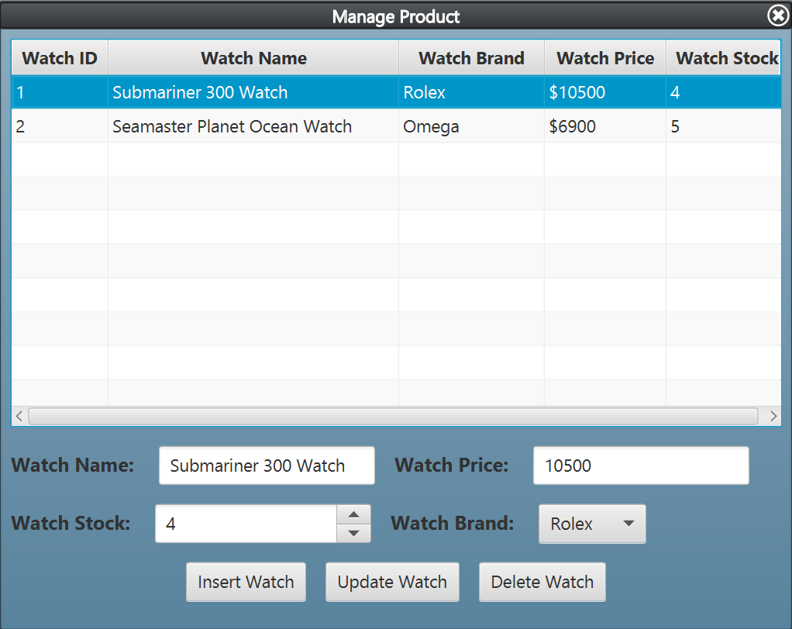
Figure 21. Manage Product Form (With One of The Watch Selected)

- If the user clicks the Insert Watch Button, then validate:
- Watch Name must end with “ Watch”.
- Watch Price must be higher than 0.
- Watch Stock must be higher than 0.
- Watch Brand must be chosen.
- If the user clicks the Update Watch Button, then validate:
- A watch must be selected from the Product Table.
- Watch Name must end with “ Watch”.
- Watch Price must be higher than 0.
- Watch Stock must be higher than 0.
- Watch Brand must be chosen.
- If the user clicks the Delete Watch Button, then validate:
- A watch must be selected from the Product Table.

- If the user clicks the Update Watch Button or the Delete Watch Button but haven’t selected any watch from the Product Table, then show the error message using Alert.
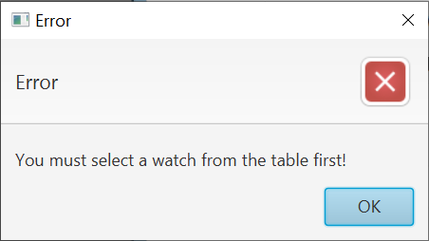
Figure 22. Clear Cart Confirmation Message
- When the user successfully Insert Watch, the program will insert a new watch into the database. The program should also reset all input fields (Watch Name, Watch Price, Watch Stock, and Watch Brand) including the currently selected watch to default. Lastly, the program will show a success message using Alert.
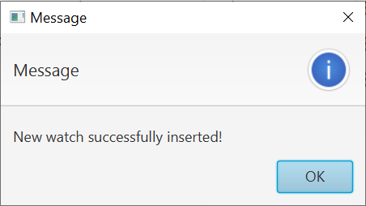
Figure 23. Insert Watch Confirmation Message
- When the user successfully Update Watch, the program will update the selected watch data in the database. The program should also reset all input fields (Watch Name, Watch Price, Watch Stock, and Watch Brand) including the currently selected watch to default. Lastly, the program will show a success message using Alert.
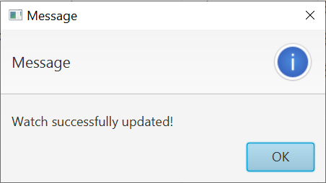
Figure 24. Update Watch Confirmation Message
- When the user successfully Delete Watch, the program will delete the selected watch from the database. The program should also reset all input fields (Watch Name, Watch Price, Watch Stock, and Watch Brand) including the currently selected watch to default. Lastly, the program will show a success message using Alert.
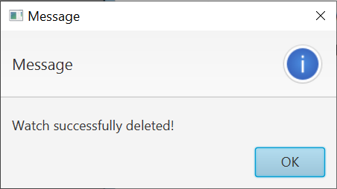
Figure 25. Delete Watch Confirmation Message
(Additional note: every error occurrence will be shown on error message using Alert).

7. Manage Brand
This form is made for admins to manage the brands of the watches. Here, admins can insert a new brand, update any existing brand data, and delete any existing brand.
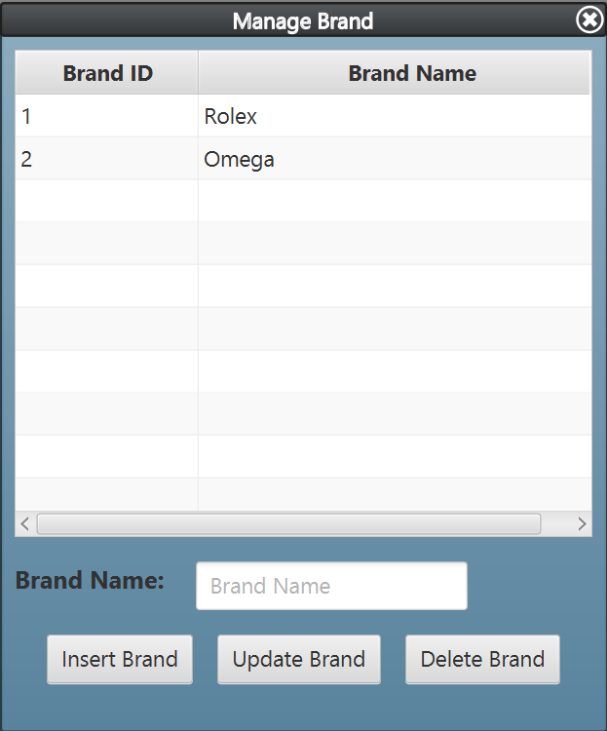
Figure 26. Manage Brand Form (Default View)
Components:
- TableView for Brand Table.
- Label for Brand Name.
- TextField for input Brand Name.
- Button for Insert Brand, Update Brand and Delete Brand.
Description:
- When the user selects one of the brands from the Brand Table, the program will autofill the Watch Brand input field with the selected brand’s name.
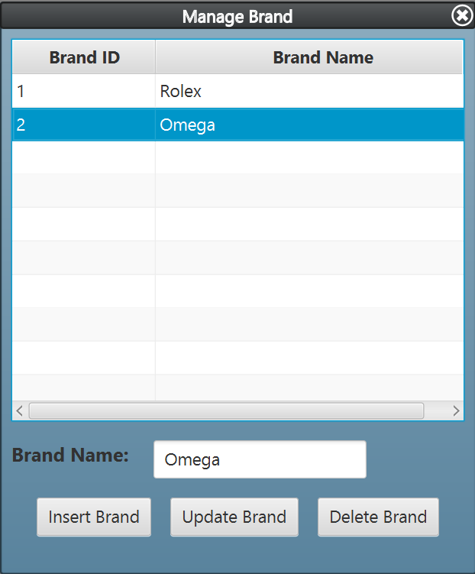
Figure 27. Manage Brand Form (With One of The Brand Selected)
- If the user clicks the Insert Brand Button, then Validate:
- Watch Brand must be filled.
- If the user clicks the Update Brand Button, then Validate:
- A brand must be selected from the Product Table.
- Watch Brand must be filled.
- If the user clicks the Delete Brand Button, then validate:
- A brand must be selected from the Product Table.

- If the user clicks the Update Brand Button or the Delete Brand Button but haven’t selected any watch from the Brand Table, then show the error message using Alert.
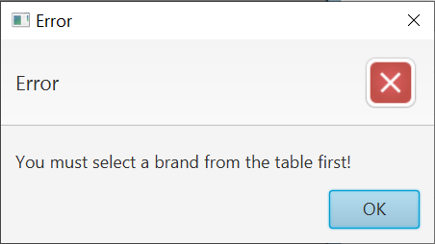
Figure 28. Clear Cart Confirmation Message
- When the user successfully Insert Brand, the program will insert a new brand into the database. The program should also reset the Brand Name input field including the currently selected watch to default. Lastly, the program will show a success message using Alert.
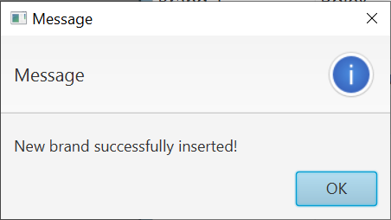
Figure 29. Insert Brand Confirmation Message
- When the user successfully Update Brand, the program will update the selected brand data in the database. The program should also reset the Brand Name input field including the currently selected brand to default. Lastly, the program will show a success message using Alert.
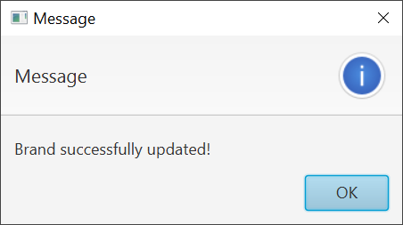
Figure 30. Update Brand Confirmation Message
- When the user successfully Delete Brand, the program will delete the selected brand from the database. The program should also reset the Brand Name including the currently selected brand to default. Lastly, the program will show a success message using Alert.
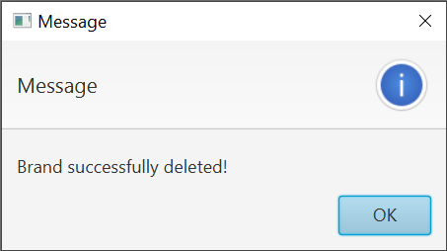
Figure 31. Delete Brand Confirmation Message
(Additional note: every error occurrence will be shown on error message using Alert).

Here are the rules that you must follow to create your project:
- Use appropriate software for this subject based on Sistem Praktikum that can be downloaded from Binusmaya.
- Additional rules:
  - All connections and data manipulation to the database must use the JDBC driver. The database file (using Microsoft Access 2003, .mdb) must be submitted as well.
  - Use LayoutManager to design your application (You are not allowed to use free / absolute / null layout!).
  - All validations must use the techniques taught during practicum. (Another language or Regular Expression is prohibited).
- Collect appropriate files for this subject based on Sistem Praktikum that can be downloaded from Binusmaya.
- Include the other files that can support your project, such as:
  - All files in your project.
  - Other files (image, audio, video, etc.) used in your project.
  - *.DOC file (documentation of your project) that contains all pages in your project, reference links of additional files (image, audio, video, etc.) used in your project, the description about how to use your application, etc.

If there is something you don’t understand, feel free to ask your Assistant

